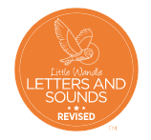

Phonics Progression at Maple Infants’ School
Nursery to Year 2

Phonics Intent
At Maple Infants’ School we believe that phonics provides the foundations of learning to make the development into fluent reading and writing accessible for all pupils. Through high quality daily phonics teaching children participate in speaking, listening and spelling activities that are matched to their developing needs. Through phonics children learn to sound out and blend words for reading as well as segment words to support spelling and early writing. Our aim is for every child to learn to read as well as being able to read to learn. Children leaving Maple will identify themselves as readers who know their phonic sounds, tricky words and are confident to attempt to read unfamiliar words using the skills they have developed during their time in our infant school.

Nursery
Foundations for Phonics contributes to the provision for ‘Communication and language’ and ‘Literacy’ (DfE, 2020) in Nursery. It sits alongside a stimulating language-rich provision. Foundations for Phonics sets out the provision that should be in place to ensure children are well prepared to begin grapheme–phoneme correspondence and blending at the start of Reception. The provision should include a balance of child-led and adult-led experiences. The most important aspects of Foundations for Phonics to develop in the nursery are:
• sharing high-quality stories and poems with children
• learning a range of nursery rhymes and action rhymes
• activities that develop focused listening and attention, including oral blending and tuning into sounds
• attention to high-quality language with children

Little Wandle ‘Foundations for Phonics’ progresses through skills and the first initial sounds termly and supports Nursery children in developing their phonological awareness.
In Autumn 1 Nursery will begin to investigate sounds completing activities such as sound walks and sound games.

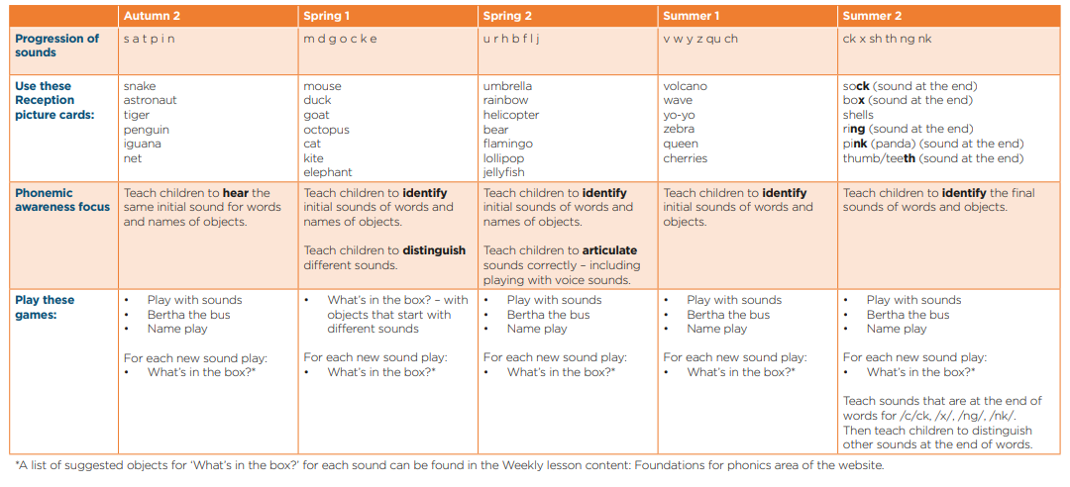
As children in Nursery begin Autumn 2 the phonics progression is outlined as follows:

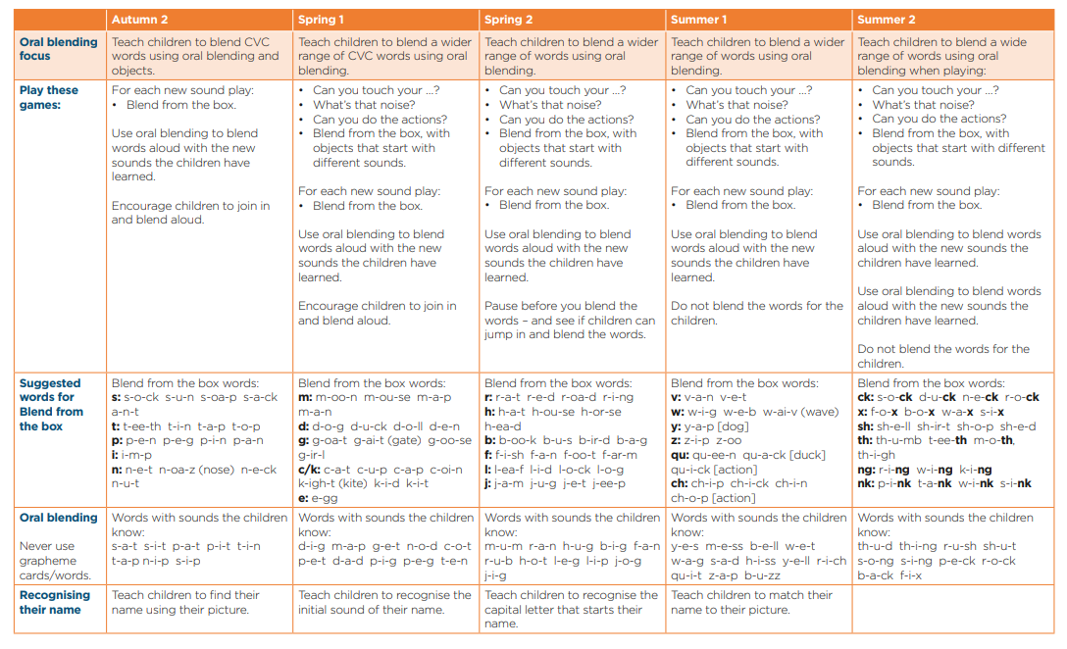


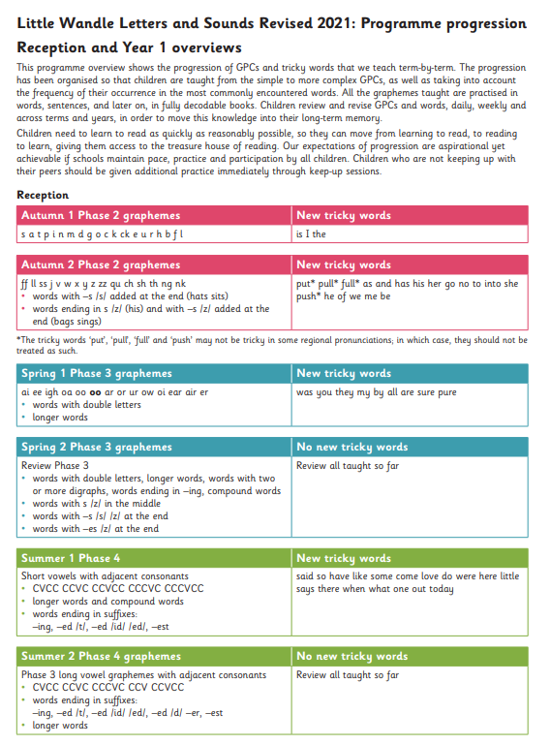

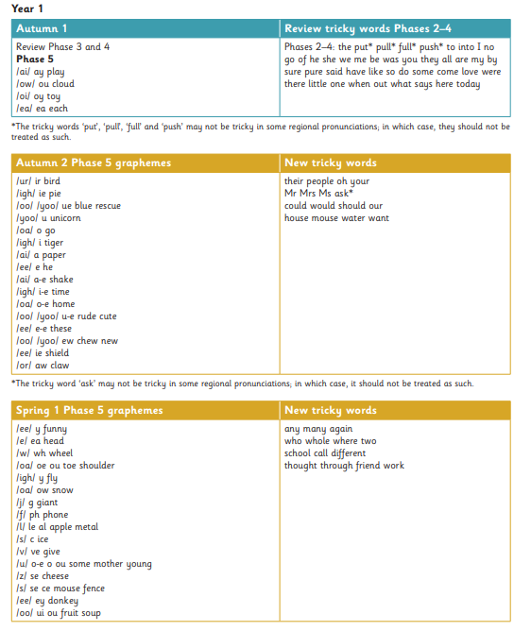

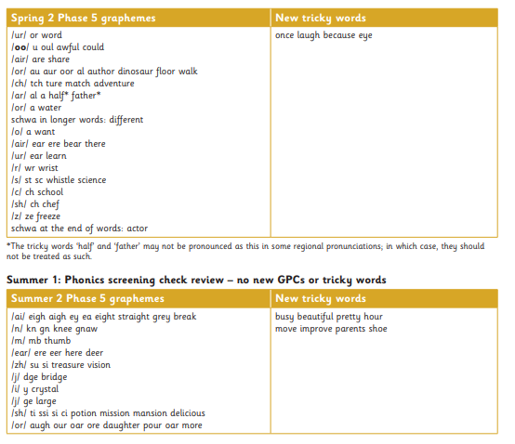

Year 2
Autumn 1

Alternative spellings/graphemes
ai, a-e, ay, a, eigh
i, ee, ea, y, e-e, ie (field)
-e, igh, y, ie , i (find)
ow, o-e, oa, o (cold)
ue, oo, ew, u-e
air, are, ear
Recap of Year 1 common exception words
Weekly spellings focus – Year 2 common exception words

Autumn 2

Sounds:
ure, or, aw, ore, au
ir, ur, er, ear (pearl)
ou, ow
oy, oi
ge/dge
/s/ sound, c before e, i and y (race, fancy etc)
Weekly spellings focus – Year 2 common exception words

Spring 1

Adding –ed suffix
Adding –ing to verbs
Dropping the –e at the end of the root word before –ing (e.g. hoping)
y is not changed to I before –ing (avoiding ii, apart from skiing and taxiing)

Adding –er to adjectives (e.g. bigger and reader)
Changing y to i before -er (e.g. happier)
Dropping the –e at the end of the root word for –er (e.g. hiker, nicer)

Doubling the last consonant letter of the root word (e.g. sadder, runner). Teaching the exception, letter x e.g. boxer
Adding -est to adjectives e.g. slowest
Changing the y to i before est e.g. happiest
The –e at the end of the root word is dropped before –est e.g. nicest
Last consonant letter of the root word is doubled to keep short vowel (e.g. biggest, saddest)

Revision of plurals adding –s and –es to nouns and verbs (e.g. cats, bushes) including words ending with –f, -x, -ch, -sh, -th, -ss, -s and –e
Adding ly to adjectives to form adverbs (e.g. sadly, happily)
Weekly spellings focus – Year 2 common exception words

Spring 2
Adding suffixes -ly , -ful, -less, -ness, -ment
Contractions- shortening words
Apostrophes – possession

Weekly spellings focus – Recap Year 2 common exception words

Summer 1
Alternative graphemes /n/, /r/ e.g. knowledge, gnome, written
Alternative graphemes /ch/, /j/ e.g. catch, giraffe, hedge

Alternative graphemes /sh/ e.g. chef, station, tissue, suspicious, confusion
Alternative graphemes /ear/, /ere/ and /eer/ e.g. beard, sphere, deer
Alternative graphemes /air/, /are/ and /ear/ e.g. chair, pear, stare
Revisit /ure/

Weekly spellings focus – Recap Year 2 common exception words

Summer 2
Spelling rules
Contractions: can’t, didn’t, hasn’t, couldn’t, it’s, I’ll
Apostrophe -‘s (e.g. Megan’s, the man’s)

Grammar rules

here/their/they’re
quite/quiet, see/sea, bare/bear, one/won, sun/son, to/too/two, be/bee, blue/blew, night/knight
table, apple, bottle, little, middle, camel, tunnel, squirrel, travel, towel, tinsel, metal, pedal, capital, hospital, animal, pencil, fossil, nostril
enjoyment, sadness, playful, hopeless, plainness, badly, merriment, happiness, plentiful, penniless, happily

Or/aw/ore/au –

Spelling rules
Short, storm, torch, sore, lawn, paws, draw, saw, shore, more, score, wore, sauce, pause, launch, cause
tion
station, fiction, motion, national, section

Weekly spellings focus – Recap Year 2 common exception words

Phonics Screening

In the Summer term of Year 1 children participate in a statutory assessment, the phonics screening check. Children are asked to read 20 real and 20 pseudo words to assess their ability to use their phonic knowledge to decode new or unfamiliar words.
Children who do not meet the phonics screening check in Year 1 receive additional, targeted support in Year 2 and they have the opportunity to retake the screening in the Summer term of Year 2.

