WC: 19/10/20 OUR WEEK IN RECEPTION
-Together we learn and grow -

INSET Day

Friday 23rd October is an INSET day, children will not attend school on this day as it is for staff training only.

A Nurturing Environment

This week we will continue to look at the book ‘Here We Are’. We will talk about our World and how we can look after it. We will think about how we have shown kindness to others and how it feels when somebody is kind to us. We will think about looking after our planet through recycling.

Phonics and early language skills

We will be revisiting all of the sounds this week s,a,t,p,i,n,m,d,g,o,c and k and we will be looking at our phase 2 tricky words I, the, to, go, no and into. The children will be assessed in the sounds and tricky words we have learnt so far.

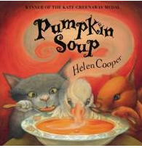
Reading

In addition to focusing on the text ‘Here We Are’ we will also be looking at other familiar texts such as ‘Pumpkin Soup’ and ‘Harry and the Bucketful of Dinosaurs Goes to School’ .

The children will complete activities linked to these stories in continuous provision, these activities will develop their skills in reading, communication and language, physical development and expressive arts and design. Using the text ‘Here We Are’

the children will focus on learning about the sea and talking about which creatures might live there.

Super stories!
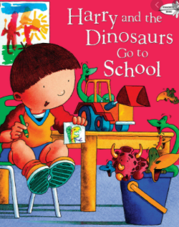
This week Miss Dowd has recorded a reading of ‘Harry and the Bucketful of Dinosaurs Goes to School’ and Mrs Miller has recorded a reading of ‘Pumpkin Soup’. These will be available on the school website on Tuesday. This will support pupils who are isolating at home, we would also encourage all children to have a listen and enjoy the stories!

Half term challenge!

The children have been working really hard to become more independent this term, please practise taking coats on and off independently including using a zip! We have been teaching the children how to turn jumpers and cardigans back the right way if they are inside out, please continue this over half term!

Additional information

We have had lots of families sharing difficulty with getting children to sleep each evening even though they are very tired. We have some information for families linked to sleep hygiene which we will send home at half term.

Have a lovely weekend!

The Reception team

